Task No 01: Write a program that prints a mosque, by using JAVA.

Code:

package com.mycompany.lab01task01;

public class Lab01task01 {

    public static void main(String[] args) {

        System.out.println("  ^              ^                 ^");

        System.out.println(" {|}             {|}              {|}");

        System.out.println(" {.}            {{|}}             {.}");

        System.out.println(" {.}           {{{|}}}            {.}");

        System.out.println(" {.}          {{{{|}}}}           {.}");

        System.out.println(" {.}           {{{|}}}            {.}");

        System.out.println(" {.}            {{|}}             {.}");

        System.out.println("{ +++++++++++++++++++++++++++++++++}");

        System.out.println("{+++++++++++++++++++++++++++++++++++}");

        System.out.println("{ |               _               |}");

        System.out.println("{ |              {#}              |}");

        System.out.println("{ |            {#####}            |}");

        System.out.println("{ |   __                    __    |}");

        System.out.println("{ |  |###|    {#######}    |###|  |}");

        System.out.println("{ |  |###|    {#######}    |###|  |}");

        System.out.println("{ |  =====    {#######}    =====  |}");

        System.out.println("{ |           {#######}           |}");

        System.out.println("{ |           {#######}           |}");

        System.out.println("{ |           {#######}           |}");

        System.out.println("{############===========############}");

        System.out.println("{$$$$$$$$$$$$===========$$$$$$$$$$$$}");

        System.out.println("{@@@@@@@@@@@@===========@@@@@@@@@@@@}");

        System.out.println("{&&&&&&&&&&&&===========&&&&&&&&&&&&}");

    }

}

Output:

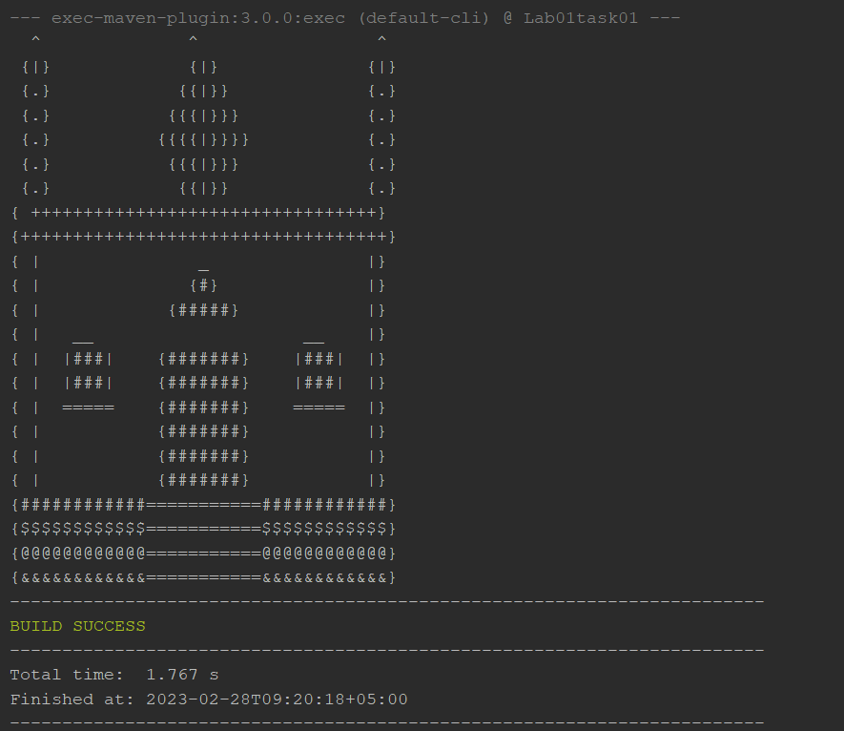

Task No 02: Write a JAVA program, which receives the input of two integer numbers, operation (+, -, *, /, %, power, square-root, and factorial) and compute athematic operations. Generate a menu for operations and ask user after every operation if they want to do another. (Hint use switch case)

Code:

package com.mycompany.lab01task02;

import java.util.Scanner;

public class Lab01task02 {

    public static void main(String[] args) {

        Scanner input = new Scanner(System.in);

        int opp;

        char rep;

        System.out.println("\n---Arithematic Calculator---");

        System.out.println("\nDo you want to perform any Arithematic Operation?");

        System.out.println(" If yes, reply with y....");

        rep = input.next().charAt(0);

        while (rep == 'y' || rep == 'Y') {

            System.out.println("\nSelect the Operation");

            System.out.println("1) Addition\n2) Substraction\n3) Multiplication\n4) Division\n5) Power\n6) Square Root");

            System.out.println("\nReply between 1 to 6....");

            opp = input.nextInt();

            switch (opp) {

                case 1:

                    double a,b;

                    double sum;

                    System.out.print("Enter the first number: ");

                    a = input.nextDouble();

                    System.out.print("Enter the second number: ");

                    b = input.nextDouble();

                    sum = a + b;

                    System.out.println("The Sum is: " + sum);

                    System.out.println("\nDo you want to perform any other Operation?");

                    break;

                case 2:

                    double sub;

                    System.out.print("Enter the first number: ");

                    a = input.nextDouble();

                    System.out.print("Enter the second number: ");

                    b = input.nextDouble();

                    sub = a - b;

                    System.out.println("The Difference is: " + sub);

                    System.out.println("\nDo you want to perform any other Operation?");

                    break;

                case 3:

                    double prod;

                    System.out.print("Enter the first number: ");

                    a = input.nextDouble();

                    System.out.print("Enter the second number: ");

                    b = input.nextDouble();

                    prod = a * b;

                    System.out.println("The Product is: " + prod);

                    System.out.println("\nDo you want to perform any other Operation?");

                    break;

                case 4:

                    double divd;

                    System.out.print("Enter the first number: ");

                    a = input.nextDouble();

                    System.out.print("Enter the second number: ");

                    b = input.nextDouble();

                    divd = a / b;

                    System.out.println("The answer is: " + divd);

                    System.out.println("\nDo you want to perform any other Operation?");

                    break;

                case 5:

                    double power;

                    System.out.print("Enter the number: ");

                    a = input.nextDouble();

                    System.out.print("Enter the Power: ");

                    b = input.nextDouble();

                    power = Math.pow(a, b);

                    System.out.println("The answer is: " + power);

                    System.out.println("\nDo you want to perform any other Operation?");

                    break;

                case 6:

                    double squareRoot;

                    System.out.print("Enter the number: ");

                    a = input.nextDouble();

                    squareRoot = Math.sqrt(a);

                    System.out.println(String.format("The squareroot of %f is: %f", a, squareRoot));

                    System.out.println("\nDo you want to perform any other Operation?");

                    break;

                default:

                    System.out.println("Invalid Input! Please reply between 1 to 6....\n");

                    break;

            }

        }

    }

}

Output:

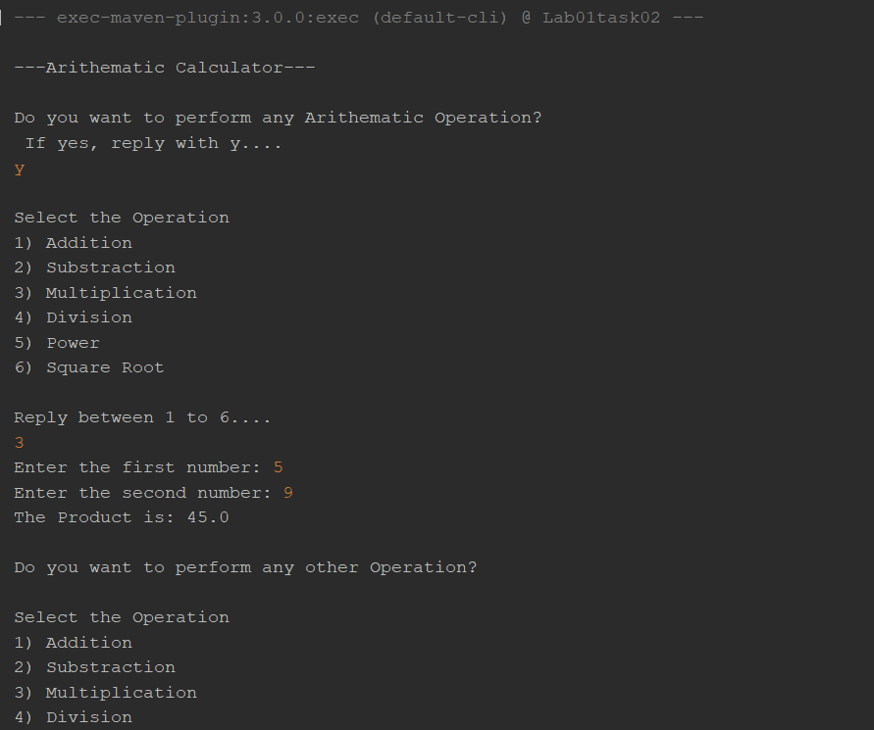

Task No 03: Make a program in JAVA in which take no. of items, price of items and name of items as input from the user and give the discount according to the following conditions:

1. If from Bahria University give discount of 30%.
2. Else if the total amount is greater than 50,000 and less than 100,000 give discounts of 20%.
3. Else if the total amount is greater than 100,000 give discounts of 30%.

Code:

package com.mycompany.lab01task03;

import java.util.Scanner;

public class Lab01task03 {

    public static void main(String[] args) {

        Scanner input = new Scanner(System.in);

        double amount, discount, total = 0;

        System.out.print("Enter the mumber of items you have purchased: ");

        int number = input.nextInt();

        int price[] = new int[number];

        for (int i = 0; i < number; i++) {

            System.out.println("Enter the name of item " + (i + 1));

            String items = input.next();

            System.out.println("Enter the price ");

            price[i] = input.nextInt();

            total = total + price[i];

        }

        System.out.println("\nAre you from Bahria University?");

        System.out.println(" If yes, reply with y otherwise n....");

        char rep = input.next().charAt(0);

        if (rep == 'y' || rep == 'Y') {

            discount = total * (0.3);

            amount = total - discount;

            System.out.println(String.format("\nYour final bill is %f Rs with 30 Percent Discount.", amount));

        } else if (rep == 'n' || rep == 'N') {

            if (total >= 50000 && total <= 100000) {

                discount = total * (0.2);

            } else if (total >= 100000) {

                discount = total * (0.3);

            } else {

                discount = 0;

            }

            amount = total - discount;

            System.out.println(String.format("\nYour final bill is %f Rs with the discount of Rs %f.", amount, discount));

        } else {

            System.out.println(" Invalid Input! Please reply with y or n....");

        }

    }

}

Output:

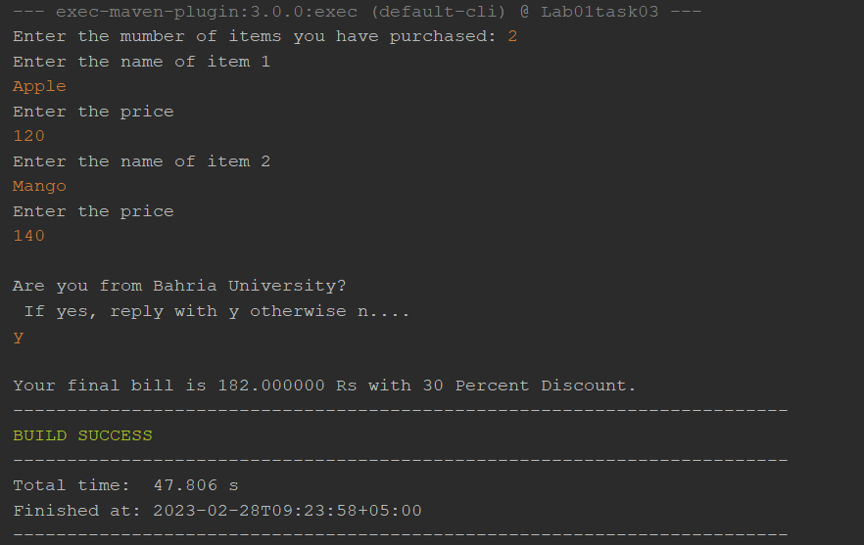

Task No 04: Write a JAVA program which will implement the following formulae using methods.

1. **Automobile Tire Pressure. P = 0.37m(T + 460)/V**

Where:

P = Pressure in psi.

V = Volume in cubic feet

m = Mass of air in pounds

T = Temperature in Fahrenheit

1. **Pulley formulas:**
2. Calculate the speed of one pulley if there are 2 pulleys connected with a belt:

RPM2 = Diameter1/Diameter2 * RPM1

ii) Calculate the amount of weight that can be lifted with a multiple pulley system:

Weight Lifted = Force Exerted * Number of up Ropes

1. **The body mass index (BMI):**

Where mass is the subject's weight in pounds (lb.) and height is the height in inches (in). The value 703 is a factor to convert BMI to a value that matches the original BMI calculations done in metric units (i.e., Kilograms-Meters).

Code:

package com.mycompany.lab01task04;

import java.util.Scanner;

public class Lab01task04 {

    static Scanner input = new Scanner(System.in);

    static double calculatePressure() {

        double p, m, t, v, a, b;

        System.out.println("\n---Automobile Tyre Pressure Calculator---");

        System.out.println("Enter the Mass of air in pounds:");

        m = input.nextDouble();

        System.out.println("Enter Temperature in Fahrenheit:");

        t = input.nextDouble();

        System.out.println("Enter Volume in cubic feet:");

        v = input.nextDouble();

        a = m * (t + 460);

        b = 0.37 / v;

        p = a * b;

        return p;

    }

    static double calculateRPM2() {

        double RPM2, a, d1, d2, RPM1;

        System.out.println("\n---Two pulleys System---");

        System.out.println("Enter the diameter of Pulley 1 (in meter):");

        d1 = input.nextDouble();

        System.out.println("Enter the Speed of Pulley 1 (in RPM):");

        RPM1 = input.nextDouble();

        System.out.println("Enter the diameter of Pulley 2 (in meter):");

        d2 = input.nextDouble();

        a = d1 / d2;

        RPM2 = a * RPM1;

        return RPM2;

    }

    static double calculateWeight() {

        double force, weight;

        int ropes;

        System.out.println("\n---Multiple pulleys System---");

        System.out.println("Enter the Force exerted (in Newtons):");

        force = input.nextDouble();

        System.out.println("Enter the number of Ropes:");

        ropes = input.nextInt();

        weight = force * ropes;

        return weight;

    }

    static double calculateBMI() {

        double BMI, a, m, h;

        System.out.println("\n---Body Mass Index---");

        System.out.println("Enter your weight in Pounds:");

        m = input.nextDouble();

        System.out.println("Enter your height in inches:");

        h = input.nextDouble();

        a = m / (h * h);

        BMI = a * 703;

        return BMI;

    }

    public static void main(String[] args) {

        Scanner input = new Scanner(System.in);

        char rep;

        System.out.println("What do you want to calculate?");

        System.out.println("a) Automobile Pressure\nb) Pulley systems\nc) Body Mass Index (BMI)");

        System.out.println("\nReply with a,b or c......");

        rep = input.next().charAt(0);

        switch (rep) {

            case 'a':

                System.out.println(String.format("Pressure is %,.2f psi", calculatePressure()));

                break;

            case 'b':

                int rep1;

                System.out.println("\n---Pulley Systems---");

                System.out.println("How many pulleys are there in your system:");

                System.out.println("1) Only two Pulleys. \n2) Multiple Pulleys.");

                System.out.println("Reply with 1 or 2.....");

                rep1 = input.nextInt();

                if (rep1 == 1) {

                    System.out.println(String.format("The speed of 2nd Pulley is %,.2f RPM", calculateRPM2()));

                } else if (rep1 == 2) {

                    System.out.println(String.format("The total weight that can be lifted with Pulley system is %,.2f KG", calculateWeight()));

                } else {

                    System.out.println("Invalid Input! Please Reply with 1 or 2......");

                }

                break;

            case 'c': {

                System.out.println(String.format("The value of BMI is %,.2f Kg/m-square", calculateBMI()));

            }

            default:

                System.out.println("Invalid Input! Please Reply with a, b or c......");

                break;

        }

    }

}

Output:

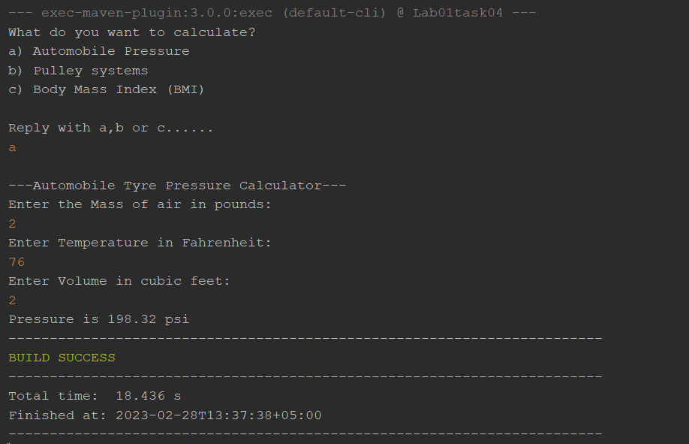

Bi)

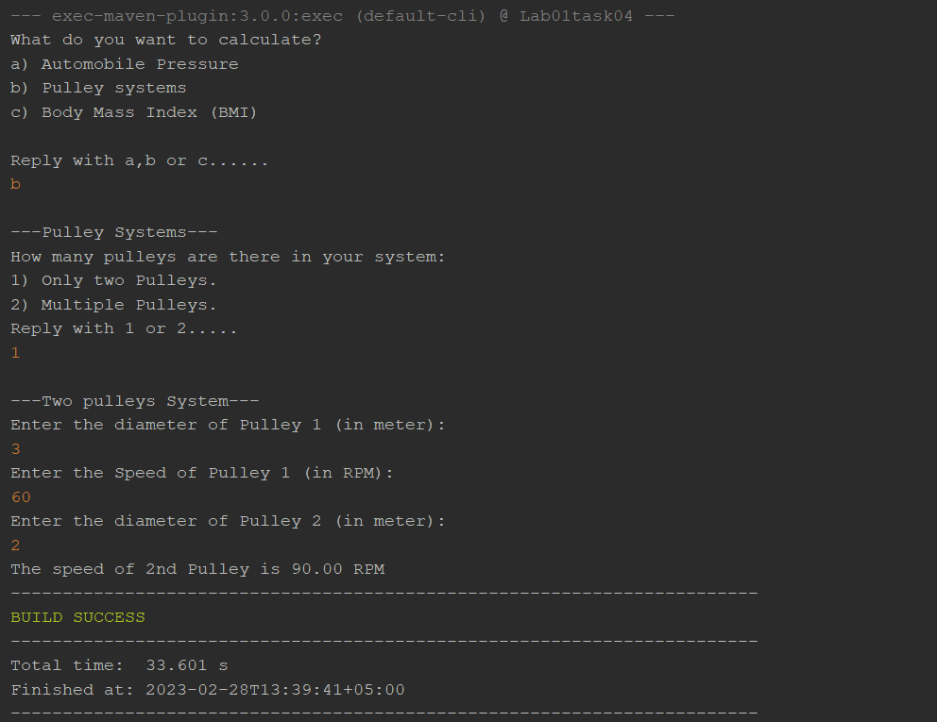

Bii)

C)

